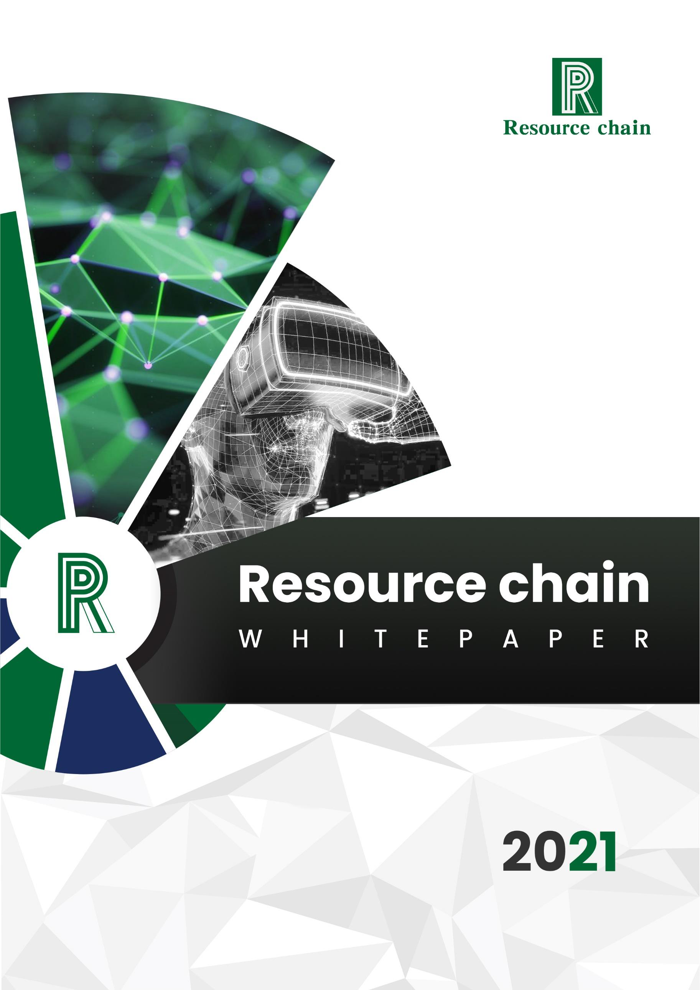

Contents CONTENTS

|  |  |
| --- | --- |
| **INTRODUCTION**  **DIGITAL FUTURE CENTERED ON META-UNIVERSE**  **PROJECT OVERVIEW**  **PROBLEMS TO BE SOLVED**  **CORE IDEA**  **DECENTRALIZED GOVERNANCE (DAO)**  **TECHNICAL TEAM BACKGROUND**  **STRATEGIC PLATFORM**  **MAIN CHAIN FUNCTION**  **MINING MODE**  **WALLET FUNCTION**  **TECHNOLOGICAL DEVELOPMENT ADVANTAGES**  **ADVANTAGES OF CHAIN TOUR INDUSTRY**  **UNDERLYING TECHNICAL FRAMEWORK**  **TOKEN ECONOMY**  **DEVELOPMENT PLANNING**  **APPENDIX** | **1**  **3**  **5**  **7**  **11**  **13**  **15**  **19**  **21**  **24**  **26**  **28**  **30**  **32**  **47**  **48**  **49** |





Introduction

With the continuous development of communication technology and

electronic technology, the game media is constantly innovating, and the

game industry has grown into a huge market of hundreds of billions of dollars.

From stand-alone mainframe to end-game to page-game to mobile-game,

the emergence of new media has brought more than 10 billion new industries.

However, the growth rate of mobile games, which has led the rapid growth

of the game industry in the past decade, is close to saturation, while the

innovation of business model has not yet been verified. The game industry

may face a rare recession in the past two decades, and a new growth engine

is needed.

The great development potential of blockchain games mainly comes from

two points. First, the growth of traditional game industry requires the

introduction of new gameplay, new modes and logic to break the ceiling of

the existing industry and bring considerable increment to the game industry.

Second,The traceability, fairness, transparency and more plastic economic

model of blockchain can help traditional games break the existing pattern

and provide new ideas and ways of playing.

In the past year, although blockchain games have developed, there are still

outstanding problems and the road to development is confusing. But in the

long run, the application of blockchain technology in the game industry will



bring unprecedented breakthroughs and changes, breaking the existing

shackles and limitations.

Resource Chain believes: 1. Community-based operation of blockchain

games will become the mainstream; 2. The profit model will be more

diversified; 3. Blockchain technology will make the game world of "meta-

universe" a reality; 4. "Explosions" game will drive the development of the

whole industry; 5. Perfect industry ecology will be an important symbol of

the eve of blockchain game prosperity.



Digital future centered on meta-universe

Countless people are eager to know how the next era after the Internet

should be defined and where the next giant will be born. At present,

Metaverse provides us with a vague and correct future direction, and is

shaping a strong social consensus.

Meta-cosmic sword refers to the ultimate direction of Internet development,

and it is a deeper practical application of virtual reality technology.

The concept of meta-universe originated from science fiction, or the

"ultimate form" pointing to the Internet. Metaverse comes from the science

fiction Avalanche by writer Neal Stephenson, which describes a world where

people interact with various softwares in three-dimensional space with

virtual images.

Conceptually, the word universe consists of Meta and Universe, Meta stands

for transcendence, Universe stands for universe, which together usually

means the concept of "transcending the universe": an artificial space running

parallel to the real world. Looking back at the development of the Internet,

from PC LAN to mobile Internet, the immersion of Internet use has gradually

improved, and the distance between virtual and reality has gradually

narrowed. Under this trend,Metaverse, where immersion and participation

have reached the peak, or the "ultimate form" of the Internet.



Technically, on the basis of the traditional Internet, the meta-universe puts

forward higher requirements in many aspects such as immersion,

participation and sustainability, so it will be supported by many independent

tools, platforms, infrastructure and protocols. With the maturity of AR, VR,

5G, cloud computing, cloud storage, cloud games, chain games and other

technologies,Metauniverse is expected to gradually move from concept to

reality.

Basically, the concept of Metaverse is a digital world, in which players can

participate in and create social and economic activities with other individuals

in a shared virtual environment. These computer-generated environments

range from detail-oriented popular destinations (such as Hawaii or inland

Australia) to the dystopian future world in our favorite movies.The

possibilities are endless.



Project overview

As an epoch-making symbol, we will demonstrate and verify how to build a

decentralized community autonomy online game asset platform.

—— Resource Chain 2021

Resource Chain (RR) is committed to building a blockchain game ecosystem.

By combining the existing HTML5 game development with blockchain

technology, it will create a one-stop blockchain game development workflow,

bringing hundreds of thousands of developers and 1 billion mobile terminal

users into the blockchain meta-universe.Resource Chain ecosystem includes

open game platform, crowdfunding platform, digital asset exchange and

incubator, providing comprehensive blockchain solutions for players, content

providers, channels and advertisers.

Most of the core members of Resource Chain come from the unreal game

engine development team, and they have 4 years' experience in HTML5

development workflow, which covers 14 development tools and all aspects

of HTML5 content development. Resource Chain will provide a block link

interface framework, which will not only support its own public chain, but

also expand to support public chains such as Ethereum and EOS in the

future.Game developers can easily and efficiently create HTML5 games

based on blockchain.



"Cosmic Pursuit" movie chain tour product of the same name

With the rapid development of Resource Chian in the blockchain game

industry, the industry popularity has increased rapidly, attracting a large

number of excellent game teams and game producers. At present, the

Resource Chain team has received investment from Hollywood film

producers, set up a game development technical team, and work together to

create a brand-new chain tour meta-universe around the movie "Cosmic

Pursuit".

|  |  |
| --- | --- |
| Problems to be solved |  |

In view of some existing problems in the game industry, Resource Chain

integrates blockchain with games, and solves the existing problems of online

games through the construction of community ecosystem. In the future,

Resource Chain will not only bring good entertainment and playability to

online games, but also bring a safer, fairer and more independent game

environment to all parties. Through the ecological construction of blockchain

community,Help players protect their virtual property from theft and loss.

Resource Chain will solve the pain points of chain tour development,

including high transaction cost, extremely slow speed, dependence on

exchanges, great uncertainty, high development threshold, high user

threshold, excessive non-game factors, poor player game experience, small

user base and no distribution channel. With the empowerment of blockchain

technology,Provide a future chain tour solution with players' experience,

independent property rights, self-consistent economic system, transparent

gameplay and no shady play, and the game is ecological. This scheme will

be able to realize the meta-universe experience of interaction between the

real world and the customized virtual world.

In fact, Resource Chain can be defined as a brand-new standard of

augmented reality experience, which is positioned as the first "browser" in

the world where users do not choose content, but the real world presents

possible experiences according to specific geographical locations.



Resource Chain adopts the concept of open source, which means that the

whole Resource Chain community contributes to its own growth, which also

makes the whole platform independent of its creator, so that it can operate

for a longer time.



Data can be trusted

Through the blockchain technology to record online digital assets, the core

data such as the content, quantity and output of virtual props in the game

are stored in the blockchain. In the whole community ecology of Resource

Chain, game companies will be supervised and can't indiscriminately

distribute game products and props. Similarly, the game data is made more

transparent and credible,Reduce various contradictions and disputes

between game companies and players caused by opaque information.

Game property confirmation

Online game is a small society, where a large number of gamers invest time

and money in the game and create a large number of virtual property.

Resource Chain will provide a safe and controllable storage method for the

protection of game property and the exchange of rights. Based on the

unchangeable and decentralized characteristics of blockchain, the

production and sale of game equipment become difficult to tamper with. In

the Resource Chain community ecology,All virtual property of players can be

preserved forever and freely exchanged.

Realize the inheritance and permanent record of the game process

Once the game virtual property is linked through the resource chain,

operations such as transfer, splitting and withdrawal will be strictly controlled

through the public and private keys of the account. All operations need

signature verification, and both sides of the transaction will leave traces.The



inheritance of game property will be permanently preserved and recorded to

establish a full emotional connection between players and digital property.In

the future, no matter when,Players can access, view and interact with each

other on the resource chain to make it an eternal memory of players, and

keep happiness and memories forever.



Core idea

Resource chain is committed to breaking through the isolated island

phenomenon in the game industry and solving the problem of game asset

ownership confirmation;At the same time, it focuses on the chain reform of

traditional game development and the infrastructure construction of meta

universe facilities.

In the field of data chain, each participant has his own unique game data on

the resource chain as long as the data is on the chain.Moreover, resource

chain helps game users to confirm the game data rights. The data owner is

the data producer himself, and others have no right to obtain and use the

data without my consent.After the user agrees with the data information,It

can be opened to game developers, game organizations, game business

organizations, game research institutions, and get the corresponding RR

awards.At the same time, the accumulation of data information also

increases the stickiness of game users, which helps to establish game users'

lifelong game files and provide long-term and effective game service plans

around the users.

In the field of chain reform, resource chain will provide one-stop online

services for traditional game development, investment and financing services

for game developers on the chain, and liquidity mining and product

preheating and drainage services for game developers.

|  |  |
| --- | --- |
|  |  |

The purpose of these is to make it easier for traditional games to enter the

blockchain industry, so that game developers with dreams can no longer

worry about operation and capital, so that users can have a player center to

exchange experiences and discover new high-quality projects;It's good to

have any wealth opportunity in the chain game.



Decentralized governance (DAO)

The decentralized operation of resource chain is inseparable from Dao

governance.As a decentralized autonomous organization, Dao maintains its

operation through smart contracts. It encodes transactions and rules on the

blockchain. It has various advantages and realizes openness, impartiality, no

intervention and independent operation. On chain voting and management of

decentralized autonomous organizations.The verifier is a distributed

autonomous group that provides and obtains benefits based on

participation.Chain tour / meta universe project can use the platform to run

Dao governance mechanism, such as proposal and voting system, community

fund collection, etc.

Resource chain will ensure the release and development of its own ecological

applications until the establishment of a resource chain community sufficient

for fully decentralized self maintenance.The Dao governance of resource

chain ecology adopts the token incentive mechanism, which will be used as

the value storage carrier to capture and solidify the growing value of the

protocol network.

As a decentralized platform, resource chain is supported by a completely

transparent decentralized autonomous system.This structure enables each

pass holder to clearly understand all the technology construction and value

flow within the public chain foundation, and fully reflects the public credit

value of the blockchain.The completely decentralized management system



of resource chain will completely avoid the disadvantages of centralized

management of traditional institutions.It provides a good and no trust risk

solution for the problems of centralized management, tampering with data

and independent decision-making group.

Resource chain is not only supported by the above-mentioned technical

features, but also employs financial audit, analysis and investment

practitioners from many global core financial institutions to join the game

financial regulatory Council, providing professional supervision and guidance

from the financial perspective.



Technical team background

|  |  |  |  |  |  |
| --- | --- | --- | --- | --- | --- |
|  | ◆ Mikhail Lukin, Professor of physics at  Harvard University  It may not take as long as 30 years for quantum  computers to move from scientific theory to  popularization.This is an exciting field. We have  entered a new era with great potential for  scientific discovery, and soon we will begin to  find that quantum computers can work on a  broader scale,It includes material science,   |  |  |  |  | | --- | --- | --- | --- | | chemistry, | physical | systems, | artificial |   intelligence and machine learning. |
|  | ◆ Christopher D. Manning  Professor of computer science and Linguistics  at Stanford University, director of the Stanford  artificial intelligence laboratory and co director  of the Institute of artificial intelligence at  Stanford human center.The software he uses   |  |  |  |  |  | | --- | --- | --- | --- | --- | | can | intelligently | process, | understand | and |   generate human language materials. |





|  |  |
| --- | --- |
|  | ◆ Bob coecke  Coecke previously served as a senior scientific consultant to  CQC to develop and build leading quantum natural language  processing (qnlp) capabilities. Prior to that, he worked at  Oxford University for more than 20 years and since 2010 has  been professor of quantum foundation, logic and structure at  the University.Bob coecke has been appointed chief scientist  in the field of quantum computing software and algorithms. |
|  | ◆ ADI Shamir  ADI Shamir is a famous international cryptography  expert, who provides many new ideas for modern  cryptography. He has been active in the forefront of  cryptography for many years, and is recognized as a  leader in the academic field. |
|  | ◆ Dr. Dan Boneh  Professor of Stanford University, his main research focus  is applied cryptography and computer security. |

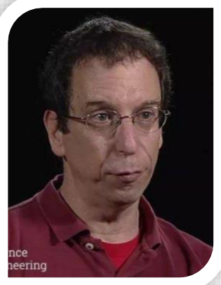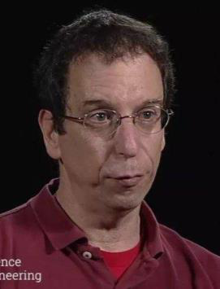



… …

We are a team founded by professors' lifelong research achievements.In the

past few years, resource chain has evolved from a research project to several

teams and self-organizing communities that have been trying to make the

vision of the world's computers a reality.

The team has been focusing on the development of new blockchain

technologies for resource chain: establishing self sovereignty data, point-

to-point e-cash protocol, cryptographic commitment protocol, on chain

meta protocol, communication protocol, smart contract, Merkel tree, storage

proof, copy proof, post, capacity proof, distributed storage, etc,Start to

promote its potential use.

The blockchain technology of resource chain will be a global open-source

|  |  |  |  |  |  |  |  |
| --- | --- | --- | --- | --- | --- | --- | --- |
| and | decentralized | new | technology | application. | Using | its | native |

cryptocurrency cross-border payment and settlement system, it will serve

global applications, and will be called resource chain or RR.Resource chain

enables developers to create arbitrary consensus based, extensible,

|  |  |  |  |  |  |  |
| --- | --- | --- | --- | --- | --- | --- |
| standardized, | feature-based, | easy | to | develop | and | collaborative |

applications.By establishing the ultimate Abstract basic layer (blockchain

with Turing complete programming language built in), resource chain enables

anyone to create contracts and decentralized applications, and set up their

freely defined ownership rules, transaction methods and state transition

functions.

|  |  |
| --- | --- |
|  |  |

At present, there are 12 science professors in the research and development

team, mainly focusing on research and development activities.Another 10

elite teams manage and implement their business plans.



Strategic platform

For gamers:

The strategy of resource chain blockchain platform aims to build a brand-

new chain game ecosystem, provide ordinary entrepreneurs or players with

a complete set of operation support such as products, marketing, payment

funds, flow, etc., and provide comprehensive and personalized services for

small online game operators through cooperation with third-party partners.

For game companies:

Resource chain will open up the links of "chain game development operation

promotion payment profit sharing", so that all partners can enjoy

corresponding rights and interests in the development, marketing, payment

and technology of resource chain community ecology,It provides a complete

blockchain operation solution for millions of on chain game developers, game

operators, community ecological builders, etc., and forms a huge blockchain

online game ecological network focusing on online game development,

operation and consumption behavior.Resource chain global game blockchain

is an integrator of channel resources,It can make game developers, traffic

channels, players, community ecological builders, operators and so on can

get their own corresponding interests.So that everyone can participate in the

operation of the game, and get rich returns.

|  |  |  |  |  |  |  |
| --- | --- | --- | --- | --- | --- | --- |
| |  |  |  | | --- | --- | --- | | Development | Operation | Promotion | | |  |  | | --- | --- | | Payment | Profit sharing | |





Main chain function

Permanent preservation of game assets on the chain

Traditional online game companies, E-sports games or online Red economy

all take game gold coins as the main value carrier, but there are some

problems such as the weakening of game value exchange, serious

centralization, insufficient customer stickiness, and difficulty in user recall

after game replacement.

From the perspective of individuals in the global game blockchain, resource

chain influences others by preserving and displaying the digital assets of

personal virtual world and creating content, and forms a unique ecological

chain of personal game assets storage and interactive sharing.In short, on

the resource chain, all virtual assets of users will be well preserved and can

be shared with others.

Asset added e-commerce capability and intelligent distribution function

In the resource chain ecosystem, participants can share or exchange digital

assets online, and everything can be easily traded. The transaction is

decentralized without any restrictions.

Resource chain provides a richer ecosystem for the game community by

joining large game companies, channel providers and players. Game players

can share other people's digital assets while managing their personal digital

assets.The distribution commission system is a very important link in the



traditional social marketing. Its playing methods are diverse and complex,

and the traditional system is weak in level and limited in coverage.

In the resource chain, the distribution of rewards for various marketing

methods is decided by the game manufacturer's suppliers and players

independently. Each interactive sharing can automatically distribute the

profits of all parties. At the same time, each participant can view the

allocation steps on the chain to ensure the fairness and transparency of the

whole process, which will produce a matrix marketing effect close to infinite

fission.



The smart contract based on blockchain runs through the whole ecology

Users get RR through community incentive mechanism (mining, participating

in games and content, sharing, distribution and other dimensions), as well as

creating personal digital assets through RR, purchasing and distributing, etc.,

will be written into the blockchain smart contract, so as to protect the rights

and interests of users.

Efficient operation of smart contract

Resource chain uses token with constant circulation for self benign operation

of community ecological internal value.With the smart contract, token is used

as the settlement token for distribution Commission, traffic advertisement

and interaction in the community, so as to improve the operation efficiency

of the game ecology. At the same time, token value-added can promote the

continuous iteration of the ecology, and make the resource chain community

ecology develop healthily and orderly.

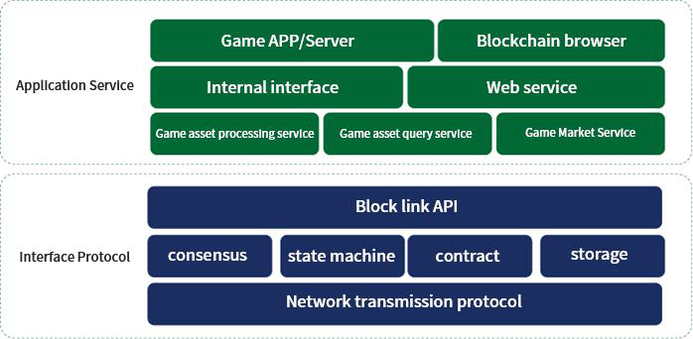



Mining mode

Resource chain mining mode is a distributed computer network composed

of game traffic nodes (such as home computers, Internet cafes, etc.)

Distributed in different regions. Each mining node provides a certain amount

of game traffic, CDN and storage capacity resources, forms a massive game

resource pool, and provides external game acceleration services.

Resource Chain mining mode carries out decentralized distributed computing

through certain redundancy and security rules, and enables users to obtain

the required game asset content safely, quickly and nearby, thus realizing

the privacy and security of user asset data.

Resource Chain mining mode can effectively reduce the construction cost of

game server resources, improve the response speed of game services and

improve the user experience. Resource Chain mining mode can make full use

of the layout and number of infinitely expanded nodes of edge nodes of

mining server, and improve the security and stability of game network.

The game traffic mining node service based on blockchain created by

Resource Chain is the industry-leading online game resource ecosystem. It

can greatly reduce the waste of personal computer computing resources,

increase the utilization rate of idle computing resources by more than 50%,

and greatly improve the utilization rate of overall social resources, which is

in line with the general trend of social environmental protection and resource

conservation.

|  |  |
| --- | --- |
|  |  |

Resource Chain mining mode is based on blockchain technology, which

naturally has decentralized and distributed attributes. The core value of the

network belongs to the resource providers and users of mining.



Wallet function

The Resource Chain wallet architecture is divided into user layer, application

layer, service layer, transaction layer and technology platform layer, providing

decentralized account management, sharing rewards, settlement interface,

secure storage and transaction, etc. The main body is a light-weight

blockchain client.

Fundamental function

Resource Chain wallet provides wallet registration, account import and

export, key replacement and other functions. The user's wallet file and

private key are kept by the user, and the user's rights are completely returned

to the user, making the system more private and secure. Once the user's

private key is lost, the wallet will never be retrieved.

Asset function

Resource Chain wallet provides the functions of asset transfer payment,

asset transfer and asset exchange. With the wallet, you can safely and

conveniently manage the digital assets of Resource Chain. Inquire about

transactions and bills of Resource Chain, so that all data of Resource Chain

are under control.

|  |  |
| --- | --- |
|  |  |

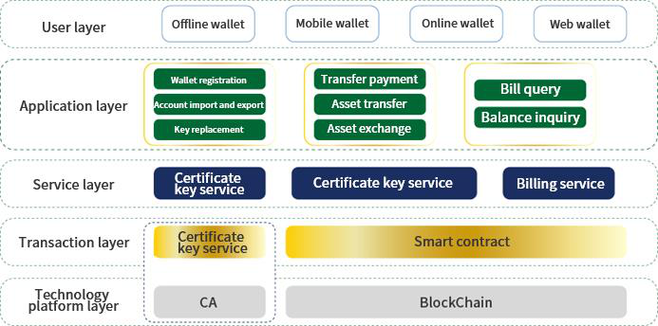

|  |  |
| --- | --- |
|  |  |

Technological development advantages



|  |  |
| --- | --- |
|  | 1. Resource Chain public chain transfer speed is fast,  reaching TPS-10w+; |
|  | 2. The public chain carries 100 billion nodes, which can  truly realize the interconnection of everything; |
|  | 3. With 10,000 sets of smart contract concurrency on the  chain, quickly promote the development of DApp; |

4. Add zero-knowledge proof to fully protect user privacy

|  |
| --- |
| and safety; |

5. Adopt post-quantum cryptography to combat quantum

|  |  |
| --- | --- |
|  | cracking; |
| 6. Self-created VDFNRF lightning consensus, using  random verification functions, second-level confirmation  and traceability; |
|  |
|  | 7. Neutral distribution network, using layering, fragmentation, and  compression transaction technology, Z.K.Rollup is compatible with more  than 90% of the public chain, and realizes cross-chain transfer and  payment; |

8. With the function of independent upgrade;

9. In terms of storage, Resource Chain adopts PoC mining, and uses

distributed computing and distributed storage technology to realize

|  |
| --- |
| big data intelligent storage and mining. |

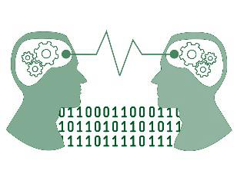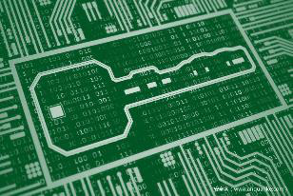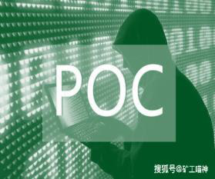



Advantages of chain tour industry

The concept of "chain tour/meta universe" rises, changes the profit model,

and players participate in/share the dividend of game development.

In traditional games, it is difficult for us to make suggestions to the project

side, and the proposed construction is also difficult to be adopted. However,

unlike chain games, chain games are decentralized projects or organizations,

in which participants can propose the game through points or some

behaviors, and participate in the governance of the game. Players will feel

that they are the owners, participants and even shareholders of the

game.More sense of participation and accomplishment.

This is the biggest promotion of chain tour to the game industry, and it is

also the biggest advantage of Resource Chain tour.

Resource Chain Tour will no longer interfere with game resources.

In the meta-universe ecology of chain tour created by Resource Chain, it

mainly relies on transaction fees to realize profits, and issues governance

tokens to gradually realize community governance. Game resources are

produced and freely traded by players. Players can get game resources for

sale by playing games, and their monthly income can be as high as thousands

of dollars.

As a result, Resource Chain Tour has changed the previous game form.

Players can find their own virtual world in the chain tour, and get behavioral



incentives that can be realized. Compared with traditional games, its value

lies in that the time spent by players in the game can be converted into pass-

through incentives. For the first time, the assets of the game really belong

to the players themselves,Game virtual assets, such as props, weapons,

characters and even gold coins, can be wound up, which means that these

data are stored in an unmodifiable and decentralized blockchain network.

Nowadays, the game industry has become a traditional mainstream

recognized by everyone. Therefore, we have higher expectations and

expectations for the game industry. At present, many traditional big

companies are running and entering the chain tour. It is expected that there

will be many interesting chain tour projects emerging next year. I believe that

the chain tour in the future will not be inferior to the traditional games at this

stage.



Underlying technical framework

Account function

User management: User management mainly solves the mapping relationship

between Resource Chain user identity and blockchain address, and the

confidentiality of user privacy.

Account management: account management is responsible for account

management of Resource Chain users, including account registration, login

and cancellation, and the irrelevance between account and key. When

registering an account, map the identity information such as user name and

password used by the original user to the blockchain address.

Key management: In the fully managed mode, the key management system

is responsible for the association between the user key of Resource Chain

and the account, key security management and lost recovery. The key is

generated by the user at the client, and the user can choose to save the key

in the key safe or entrust it to an associated account so that the key can be

retrieved after it is lost.In ord to ensure that reliability of the relationship

between the user account and the key, the key management system store

the signature of the relationship in multi-node chain.

Authority: Authority management module is responsible for the control and

management of authority such as user account, key system, node joining and

exiting, data access, etc. Include account delegation authority, node



consensus authority and user data access authority. Audit authority is to

provide audit function for regulatory agencies, and strictly control access

authority and data range.Users who share the irrelevance of transactions in

books can be associated with each other. Account delegation authority is

used to control the access control of user account delegation relationship.

Consensus authority manages consensus authority for participating or newly

joined nodes, and access authority is used to manage the data query

authority of the client on the blockchain.



Heterogeneous chain structure

In the traditional Internet, we usually use the browser to enter the website

address, and click the page link to access the resources inside or outside

the station to get information.

In technical terms, it refers to cross-network call access in the vast Internet,

and behind this, DNS(Domain Name System), one of the basic protocols of

the Internet, has made great contributions. The value internet constructed by

blockchain is a huge network cluster all over the world. Each blockchain and

subnet generate the same or different services and provide different

services.There are also a large number of cross-chain (domain) requests

between different chain networks, and the stable operation of clusters

provides a good value transmission service for human beings.

Drawing lessons from the successful experience of DNS, Resource Chain

puts forward the heterogeneous chain network architecture, which builds a

bridge between the real world and the digital world to realize the definition,

storage, transfer and conversion of resources and assets on the value

Internet, thus promoting the integration of value Internet services and

traditional Internet services.

Digital fingerprint (DF)

In the field of games, real-name authentication is the precondition of value

interaction between players and game developers. At the same time, because

in the Resource Chain game ecology, the value generated by game players



and developers far exceeds that of traditional games, it is particularly

important to determine the right of value assets.

In the core architecture of Resource Chain, the first problem to be solved is

the confirmation of rights by digital fingerprints and mutual verification. In

the account management system of Resource Chain, digital fingerprint

verification will be carried out on the personal identity of gamers, the identity

of asset owners and the identity of resource owners respectively. Personal

identity information is verified by digital fingerprint signature,The verified

identity information will be stored in. Resource verification ensures the

ownership of game development rights and the permanence of profit sharing

and revenue.

All verified digital fingerprints will be securely encrypted through the

Certificate Authority mechanism, so as to ensure the privacy and security of

the authorized and responsible individuals while ensuring the right and

responsibility. Cryptography is the core of digital encryption. The process of

converting plaintext into ciphertext through encryption algorithm and

encryption key, while decryption is the process of restoring ciphertext into

plaintext through decryption algorithm and decryption key.

In Resource Chain, the security of key does not need centralized trust

authority to issue, but through decentralized certificate chain witness

mechanism, with CREM economic model framework to generate fair super

nodes to issue and chain, which not only avoids centralization, but also

clarifies the rights and responsibilities of issuing, so as to be orderly and



efficient. In addition,A permission model is established in the account

management system of Resource Chain. The rights management mechanism

is adopted to specify the rights content in the form of signature authorization.

Usually power is tied to individuals or groups of individuals that can be

classified.

Resource Chain implements a declarative rights management system, which

allows the account to control who can do what and when at a fine-grained

and high level. Each account can be controlled by any weighted combination

of other accounts and private keys. This mechanism creates a hierarchical

authority structure that can truly reflect the organization of authority in

reality,And make it easier for multi-users to control funds than ever before.

Multi-user control is the most important factor to improve security. If used

correctly, it can greatly eliminate the risk of hacker theft. For example, there

are many services for playing gold coins or props in current games. In the

past, users often needed to give their account numbers and passwords to

the players. And through permission mapping,The game operation authority

can be granted to the proxy account by authorization. To authorize future

generations to play accounts, they need to use their own key to sign the

login operation. Asset transaction authorization is not included here, thus

improving the security of the account.



Decentralized computing power cluster (DCC)

At present, the speed of block-out in the industry is relatively restricted by

consensus agreement. After consensus optimization, Resource Chain can

achieve second-level block-out through pog consensus, and it is driven by

technology to the forefront of the whole industry. However, this is still far

from enough for the interaction efficiency required by millisecond games.

While continuing to optimize the consensus algorithm, Resource Chain has

also developed a set of millisecond response data interaction and processing

system driven by DCC+RDSN, which can meet the speed/efficiency

requirements for running large-scale games on the chain, while the existing

technology can achieve it. In order to solve the current pain point of

blockchain games-speed bottleneck, establish industry standards.Realize

millisecond data processing response, and ensure the ecology of all high-

concurrency games.

After in-depth research, the technical team of Resource Chain first proposed

the Decentralized Computing Cluster (DCC for short), that is, in the form of

distributed computing cluster, it can efficiently complete the logical

computing and interactive services in game running, break through the

existing blockchain public chain, and still cannot support the bottleneck of

high-frequency data interaction in games (including computing power/state

storage/persistent storage, etc.).

Although the existing cloud resource services can meet the demand of

medium and high frequency data interaction to a certain extent, they still



face the problems of high centralization, and the stability and security cannot

be guaranteed. With the node program client equipped with Quorom Protocol

provided by Resource Chain, cloud computing resources can be efficiently

deployed,The original centralized service is replaced by distributed

computing power cluster, and the coexistence of efficiency and security is

ensured by decentralized resource coordination. Quorom Protocol completes

the decentralized ecological network operation with a two-tier structure.

In this structure, the Master node matrix composed of Master Standby and

Backup Master ensures the high availability of scheduling resource nodes.

Agent matrix accesses bandwidth resources, computing power, etc., to

complete logical services of different resource types of games. To ensure

the efficient operation of DCC and the quality and stability of each resource

node,All nodes must meet the ecological access standard and be authorized

before they can be incorporated into the Resource Chain DCC ecological

network.

Decentralized operation of autonomous economic system

In order to ensure the effective utilization of resources in DCC ecology.We

do not adopt the traditional mode of fixed super nodes + spare

nodes.Considering the expansion of the ecological development of resource

chain and the adaptability of the whole DCC network, DCC operates in a

decentralized and self consistent economic system, with an automatic

reward mechanism, and through the spontaneous regulation of the market

economy model, it achieves decentralization,In the case of no human



intervention, the computing resource nodes can automatically allocate and

control the supply-demand relationship through the Crme model, adjust the

number of nodes incorporated into the network, realize the self-consistent

ecosystem of resource allocation, resource utilization and reward in the

whole ecosystem, achieve the optimal distribution and utilization of

resources, and ensure the enthusiasm and stability of node resource

providers,To ensure the permanent online computing power, high-efficiency

interaction with high-frequency data, to meet the millisecond processing

requirements of the game.

In the actual operation process, DCC evaluates the computing power demand

to be responded through performance evaluation, and determines the

required amount of computing power resources. Then, through the matrix

scheduler, it dynamically schedules the node resources such as memory,

bandwidth and computing power that match the demand, so as to achieve

high efficiency and stability;After deployment to the required resources, DCC

will obtain the corresponding service packets from rdsn,The isolation

container of a single service is formed to delimit the exclusive computing

power range for the service program to be run, and the redundant mirror

copy of the service program is generated to realize the global multi node

resource backup for cross validation.In this way, not only the computing

power required by the service is stable and undisturbed, but also the

operation of the master node can be verified,Such as computing power

confirmation, preventing data tampering and so on, it makes multiple

protection and verification for the safety and reliability of data.



The data generated by the server in the isolation container will interact with

the client through the lightning gateway.Lightning gateway can provide

efficient and stable data interaction services, automatically match the

nearest and fastest DCC computing power nodes for users, and achieve

rapid response to delay sensitive and high-frequency services in the

network.In addition to solving the bottleneck of the operation speed of the

blockchain game industry,Compared with the traditional centralized cloud

server, DCC can effectively solve the cheating in the game in the way of

decentralization.

For example, in the game skill trigger, damage output, the burst rate of props

and equipment and other random numbers.Generally, game developers and

operators control the core value of the game through the centralized server

in a dark box.As a result, the game's playability, fairness and continuous

operation ability are affected.Based on the characteristics of smart contract

and multi node resource distribution, decentralized computing power cluster

builds a solid defense wall for resource chain ecology, ensuring the fairness

and playability of the game.

Standard access license

Resource nodes must not only meet the requirements of specific memory

space, bandwidth space, CPU performance, region and so on, but also need

to pay a certain amount of RR as margin, so that the node can go online to

provide services and obtain revenue.When a node fails to provide stable

resources or conducts malicious behavior directly, which has a negative



impact on the whole architecture,Crme model will automatically deduct the

deposit deposited by nodes, and regard it as the reward for honest nodes

who make contributions to eliminate negative effects, so as to increase the

self-discipline of each node.

Minimal node incorporation

Under the operation of quorum protocol (smart contract based on DCC),

resource nodes that meet the admission criteria and obtain approval

certification will be incorporated into the DCC ecological network of resource

chain.In order to complete the "minimalist" integration at the technical level,

the resource chain will provide dedicated BPP program ports for each

node,After running the program port, the global distributed node servers can

be integrated into the DCC ecological scheduling network with one

click.After the successful integration of the participating computing power

scheduling, the RR benefits will be obtained through the automatic reward

mechanism.



Redundant distributed storage network (rdsn)

The biggest value of blockchain games to players is based on the economic

benefits of playability. Without the arbitrary control of centralized game

operators, the value and benefits of roles, props, equipment and virtual

assets in the game are returned to players.

Therefore, players have rigid requirements for the permanent storage of

game data.At the same time, in order to solve the efficient storage and

effective call of large static data in the whole ecological network of resource

chain.The resource chain technology team has built the redundancy

distributed storage network (rdsn) by using kad algorithm, DHT, P2P network,

TCP protocol and other technologies.Through redundant distributed node

storage network, data storage will become efficient and reliable.For the

game, it avoids the centralized data storage mode of the traditional game

service operators. Therefore, even if the developers run away, the value and

assets held by the players will not be lost. At the same time, the game itself

can be forever on the chain.

Rdsn is a distributed version storage protocol which uses hash table

technology.In this network, large static data files such as game resource

download package and patch will be divided into fixed size data blocks (each

block is no more than 4MB).

After the data is partitioned, it is distributed stored in each resource node in

the form of encryption through the data encryption protocol, and the

resources are synchronized quickly by means of P2P network.The P2P

|  |  |
| --- | --- |
|  |  |

network built by resource chain mainly adopts kad algorithm. Kad is a

distributed hash table (DHT) technology. DHT algorithm uses distributed

hash table service on resource number and node number.In other words, the

data will not be indexed in the form of file name, but will be segmented by

hash table and file content summary (sha256) using the uniqueness of

hash.This will improve the search efficiency and realize the fast and accurate

data routing and positioning in the distributed environment.

In addition, all data are backed up redundancy through redundancy

replication protocol to avoid single node file damage, data loss, network

failure and other factors affecting data integrity.In rdsn architecture, the core

is the real data verification, efficient storage and call.



|  |  |  |  |  |  |  |
| --- | --- | --- | --- | --- | --- | --- |
| |  |  | | --- | --- | |  |  | |  | |  | |  | |  |

Verification mechanism

In order to ensure that the data of each node is true and effective and prevent

false nodes from broadcasting, the resource chain uses automatic

compensation and hash index to verify the data authenticity.In other words,

each node must complete the data feedback through hash summary.Only

when the verification is successful can it be integrated into the rdsn network.



Efficient storage and transfer

According to the call frequency of data, rdsn divides the storage

requirements into three categories: high frequency / intermediate frequency

/ low frequency, and optimizes the configuration according to different

requirements

A. Special node "super miner" is equipped for high-frequency

demand, which focuses on processing high-frequency interactive

data to ensure efficiency and stability;

|  |  |
| --- | --- |
|  | B. If demand will be processed by large-scale and large-scale  intelligent hardware, which is an important resource node in the |

whole distributed network architecture. It is developed in the form

of intelligent products, enabling the scientific and technological

upgrading of intelligent products;

|  |  |
| --- | --- |
|  | C. Low frequency requirements will be redundant storage through  the external distributed network to deal with low frequency and no |

frequency requirements. Due to the low utilization rate of such data,

it will be stored in the distributed external network to meet the

accidental call demand and ensure the permanent preservation of

information.

When each node realizes data classification storage, it uses TCP protocol to

establish connection with adjacent nodes. When establishing connection,

automatic compensation mechanism is used to realize authentication



"handshake" communication process, which is used to determine protocol

version, software version, node IP, block height, etc.After identification,

according to the frequency of data interaction in the network,The path of

data storage resource node is allocated and dynamically updated and

optimized.Therefore, compared with the traditional cloud storage, in the rdsn

network, the data access speed is faster, more secure and more durable. In

combination with the redundancy of the resource chain super node, the game

resources are permanently online.



Token Economy

Token Name: RR constant issue: 36 million

|  |  |  |  |  |  |  |  |  |  |  |  |  |  |  |  |  |  |
| --- | --- | --- | --- | --- | --- | --- | --- | --- | --- | --- | --- | --- | --- | --- | --- | --- | --- |
| Infrastructure  construction 5%; | |  |  |  |  | | --- | --- | --- | --- | | NFT | DeFi | Private | Infrastructur | | placement | e | | 5% | | 5% | 1% | construction | | Chain Tour | 5% | | Community | | distribution | | 36% | 48% |   Infrastructure construction |
| Community  distribution: 48%; |
| Chain Tour: 36%; |
| NFT：5%; |
| Defi：5% |
| |  |  | | --- | --- | | Private | placement: |   1% |

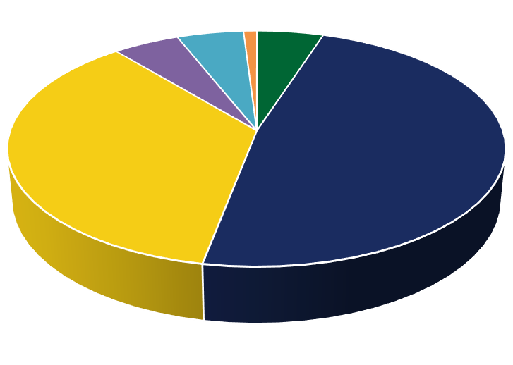

|  |  |
| --- | --- |
|  |  |

Development planning

2021年

Launched the first chain game and meta universe game platform, RR went online

on the exchange; Resource Chain DAO global community autonomous alliance

organization was established.

2022年

The construction of the main body of the public chain is completed, the ecological

structure of the chain game meta-universe is improved, the game API interface

based on the NFT standard is established, and the traditional game-related

enterprises are connected; the development of wallets and DApps is started, and

the internal testing is developed.

2023年

More trading functions of the chain game Meta universe platform are open, and

the game ecology is gradually improved; Meta universe check-in services are

provided, and game scenes are started to be built; more game ecological

development and applications are developed.



Appendix

Risk tips

There are various risks in the development, maintenance and operation of

resource chain, many of which are beyond the control of resource chain

developers.In addition to the other contents described in this white paper,

participants are requested to fully understand and agree to accept the

following risks:

Market risk: the price of RR is closely related to the situation of the whole

digital currency market. If the overall market price is low or there are other

uncontrollable factors, the price of RR may still be undervalued for a long

time even if it has a good prospect.

Regulatory risk: as the development of blockchain is still in its early stage,

there are no relevant regulatory documents in the world such as pre

requirements, transaction requirements, information disclosure requirements,

lock-in requirements and other relevant requirements in the process of

raising funds.At present, how the policy will be implemented is still unclear.

These factors may have an uncertain impact on the development and liquidity

of the project.Blockchain technology has become the main object of

supervision in major countries in the world. If the regulatory body interferes

or exerts influence, resource chain may be affected by it, for example, the

use of RR may be restricted, hindered or even directly terminated the

application and development of RR.

|  |  |
| --- | --- |
|  |  |

Competition risk: at present, there are many projects in the blockchain field,

and the competition is very fierce. There are strong market competition and

project operation pressure.Whether the resource chain project can break

through many excellent projects is widely recognized. It is not only linked

with its own team ability and strategic planning, but also influenced by many

competitors in the market, which may lead to vicious competition.

Risk of brain drain: resource chain gathers a talent team with both vitality

and strength, and attracts senior practitioners of blockchain and technical

developers with rich operation.In the future development, we can not rule out

the possibility that the overall resource chain will be negatively affected by

the departure of core personnel and conflicts within the team.The

accelerated development of project technology risk cryptography or the

development of science and technology, such as the development of

quantum computer, or bring the risk of cracking to the resource chain

platform, which may lead to the data loss of resource chain.

In the process of project updating, loopholes may appear, which will be

repaired in time after they are found, but there is no guarantee that they will

not cause any impact.In addition to the risks mentioned in this white paper,

there are also risks not mentioned or anticipated by the founding team.In

addition, other risks may arise suddenly,Or in the form of a combination of

multiple risks already mentioned.Before making participation decision,

participants should fully understand the team background, understand the

overall framework and ideas of the project, and participate rationally.



Disclaimer

This document is for information purposes only. The content of this

document is for reference only and does not constitute any offer, solicitation

or offer to sell shares or securities in resource chain and its related

companies.This document does not constitute and is not understood to

provide any transaction, nor is it a contract or promise in any form.Given the

unforeseen circumstances,The objectives listed in this white paper are

subject to change.While the team will do its best to achieve all the objectives

of this white paper, all individuals and groups that purchase RR are at their

own risk.The content of the document may be adjusted in the new version

of the white paper as the project progresses. The team will publish the

updated content to the public through the announcement on the website or

the new white paper.This document is only used to convey information to

specific objects who actively ask for information about the project. It does

not constitute any investment guidance in the future, nor any form of

contract or commitment.